

**A Responsive and Bilingual E-Commerce Website For**

**Balloony Land- Revised**

**Date: 26th April, 2016**

**Refrence # NWS/MK01/2604/2016**

**Table of Contents**

**I. EXECUTIVE SUMMAR****Y** **5**

**II. Why Mawaqaa****?** **6**

**III. PROJECT OBJECTIV****E**  **1****0**

**IV.**  **Understand client requirement****s**  **1****0**

**V. PROPOSED SOLUTIO****N**  **1****1**

**VI.**  **Scope of Wor****k**  **1****6**

**VII. Project Execution Approac****h**  **2****7**

**VIII. The project proces****s**  **2****8**

**IX.**  **Hardware Specification detail****s**  **2****9**

**X. System Development Life Cycle (SDLC) Proces****s**  **3****2**

**XI. KEY ASSUMPTION****S**  **3****4**

**2 RESPONSIBILITIE****S**  **3****7**

**3 PROJECT PLAN & TIME ESTIMAT****E**  **3****9**

**4 PROJECT COS****T**  **4****1**

**5 TERMS AND CONDITION****S**  **4****2**

Dated: 26th April 2016

To: ***Balloony Land***

Attn: **Mr. Yousef Al Dhubaib** –Owner/Director

**Subject: E-Commerce Project Proposal**

With reference to the above subject, we would like to submit our proposal for designing and implementing the web project described below for your kind evaluation.

**Project Title**:

***A Responsive and Bilingual E-Commerce Website for Balloony Land***

**Summary:**

This is to develop a user friendly E-Commerce website using the most up to date technologies to present the newest look and feel concepts in the world. The website will present all corporative information related to Balloony Land products. The system will be supported by a CMS to manage the contents of the website.

Please do not hesitate to contact us for any clarifications.

**Mohamad Khanfar**

**Account Manager**

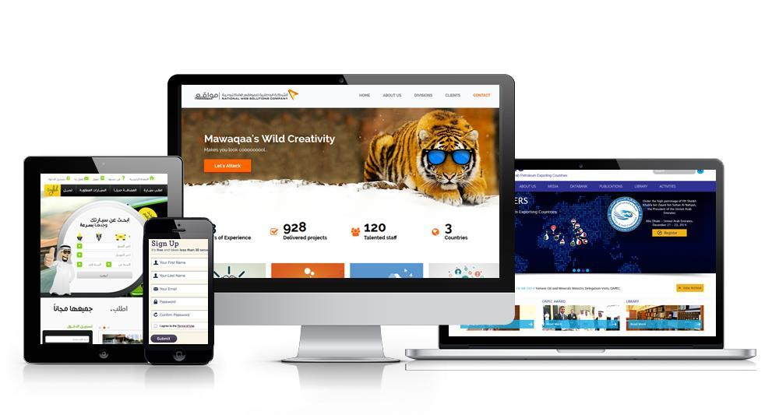

This proposal was prepared in accordance with Balloony Land invitation and submitted requirements. This proposal is composed of project objective, scope, assumptions, technology, duration, terms and condition, and project costs.

**I. EXECUTIVE SUMMARY**

Mawaqaa is well positioned to execute fully and professionally upon the key requirements and objectives by providing a flexible, professional managed service offering, which will be delivered in line with the requirements, timelines and budgetary confines. Particular emphasis will be paid to the following critical deliverables

1. Project Charter and Project Plan
2. SRS/BRD sign-off
3. Branding, Images etc.
4. Design Sign-off
5. UAT Sign-off
6. Go-Live Certificate

We believe that this response demonstrates our ability and service capabilities to provide professional services and would welcome the opportunity to discuss its content and manner in which we will deliver the service in greater detail at your convenience.

**II. Why Mawaqaa?**

**The Question is always about How to choose the right vendor and the right partner to our business success and why the online presence is that much important for the success?**

To answer this question we have to think a little bit deeply on why the website is important now a day. It is not any more a few online published pages with logo and welcoming message, It is an identity that need to be reflected through the branding and introducing yourself, positioning your business and capabilities in the market, it is a communication channel to share information, knowledge and experience, talk to a target audience to satisfy their needs, expand with the business and to be available for every one anytime and anywhere in order to enhance the company performance, and sustain the competitive advantage.

We at Mawaqaa have the faith to be your best partner to grow your business with, below you will have a list of our strength in the market and our vision for the Balloony Land web project.

1- We are passionate, energetic team, love what we do and respect what we are doing

2- Dedicated talented staff for each project with more than 17 years accumulative staff experience in the field

3- Professionality is our muscles, and creativity is our brain 4- We listen carefully to the details

5- Focus on providing high consultation service not only implementer so we share the customer and guide him for better business strategy for the online presence

6- Challenge taker for launching state of the art website and solution 7- We Deliver what we Promise

8- We do not outsource the project or team 9- Full time deducted team for your project 10- Follow up on our clients

11- Proud about our 14 years on the market

12- Focus on grow with customer as partner in success

**6**

13- Each project is not just a row on the client list, its future relationship

14- Mawaqaa is Specialized Web Solution Company that focus on providing the high end quality up to international standard

15- 130+ talented members

16- Located in 3 countries (Kuwait, Dubai, and India) 17- 50+ Ongoing Client

18- 83% Repeated Client

19- 95% new business form referral

20- Focus of providing UX - User Experience not only UI - User interface

21- Team will consist of project manager, design team leader, developing team leader, designer, developer and auditor.

22- Designing award winning websites

23- Through our business journey we focused on providing our service to the biggest customer in both Kuwait and Dubai such as:

1. Protocol Department – Dubai, Shaikh Mohammed bin Rashid AlMaktom website
2. Council of Ministers General Secretaries - Kuwait
3. Public Institution for Social Securities - PIFSS (2 Award Winning for the best website)
4. KNPC
5. EQUATE
6. OAPEC
7. Commercial Bank
8. Mazaya Holding Company
9. Capital Markets Authority – CMA
10. Al Salam International Hospital
11. Ministry of Health
12. Ministry of Finance
13. Public Authority of Minor Affair – PAMA
14. KFH
15. KIPCO Group
16. Investment Dar

**7**

1. Kuwait Finance and Investment Company – KFIC
2. Talabat website
3. AlGhanim Industries Group
4. Al Mal Investment
5. 360 Mall
6. The Avenues
7. Zakat House
8. Al Babtain Group
9. Alzayani Automotive and trading
10. Tijara Real Estate
11. Advanced Technologies Company – ATC
12. AlMulla Group
13. KFAS
14. Central for Research and Scientific Studies – Kuwait (CRSK)
15. Kuwait Institute of Banking Studies – KIBS
16. Information Turnkey Solution - ITS
17. Noor Investment
18. First Dubai Real Estate Development company
19. And more, check the link  [http://mawaqaa.com/clients.htm](http://mawaqaa.com/clients.html)l

**8**

**Mawaqaa Certified Partner**



Official Microsoft Certified Partner for Share

Point Integration.



Gold Partner with Composite C1 for Content

Management System



Official Partner with HubSpot for Inbound

Marketing Solution

**9**

III. **PROJECT OBJECTIVE**

The main objectives of this web development project is to create and build website

as per the latest look and feel that reflect the company products. The developed

website reflects the most up-to-date features of web technologies, website

usability, creativity, User Experience, and the latest trend in the international

market. It will ensure all security issues and flexibility of a Content Management

System and all other Add-on tools and modules, in addition to be available

everywhere and anywhere using the website responsive features.

Mawaqaa will achieve these objectives by analyzing, designing, implementing and supporting a comprehensive web development strategy that incorporates brand immersion, a compelling website experience, strategic content placement and user-centered value added services.

**IV.** **Understand client requirements**

The aim of this project is to develop an e-commerce website to present the products and services provided by the company. The website must support both Arabic and English, and it has to be responsive, which means to support the most new mobile devices.

Following are the website general features:

1. E-Commerce system.
2. Responsive website
3. Mobile Application (IOS & Android)
4. Bilingual English & Arabic
5. Customer registration is required for purchasing and payment.
6. Payments are online through KNET / Credit Cards.
7. The vendors will receive an email after each purchased order to get it prepared.
8. Event Module for booking events
9. Plan your events section where you can build and customize your order
10. Promotions section

**10**

**V. PROPOSED SOLUTION**

1. **Overview**

As per the Balloony Land web project requirements and Mawaqaa recommendation to achieve the goal. Below is our recommended solution described in details and supported with diagrams and pictures. **All presented** **pictures and diagrams are for illustration purpose only and doesn’t represent the actual design**.

1. **Workflow Process**

The web based part of the system will have two parts by itself, a website and a Content Management System CMS that is controlling the content and the flow of the website information. Based on the assigned privileges, different staff members will have access to different parts of the system. The administrator will have all privileges.

Figure below explains how the system will work. The admin (The owner of website) is the one who has all privileges on controlling the website actions and can see all transactions. The admin gives the rights to the interested suppliers to have their own space within the marketplace. After then each cooperative society will be able to upload its products and product details to the market, where public users can review and add the interested items into their shopping cart.

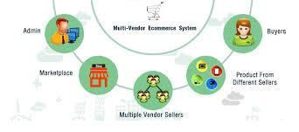

When public users have purchased the products and completed the payment process, an order request will reach to each vendor whose products were purchased by the customer.

**11**

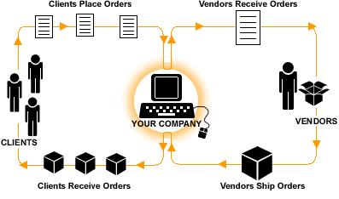

According to the agreement between the website owner and the suppliers, an email will reach to the responsible employer for the delivery task. The email contains Vendor’s Name, Vendor’s Address, Customer Name, Customer Address and the list of purchased items from that specific vendor.

1. **E-Commerce General Features**

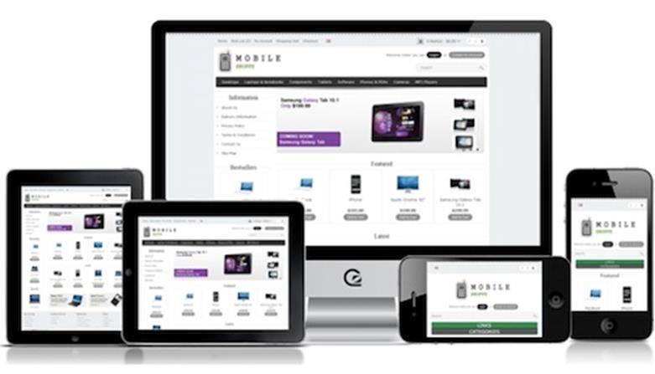

The e-commerce system is an "out of the box" shopping cart solution that provides a user friendly graphical interface to add products and start accepting orders. It has order management and multiple payment gateways already built in. Following are the characteristics of an e-commerce system:

**12**

1. Unlimited Categories
2. Unlimited Products
3. Unlimited Manufacturers
4. Multi-Stores; to allow the admin/s manage many stores from one admin panel. This has following advantages:
   1. Theme each store differently to match the products that are being sold.
   2. Set products to appear on specific stores.
   3. Localize each store by setting a different default language, currency and tax class.
   4. You can set different prices & charges for each store you have setup.
   5. Setup a default customer group for each store allowing you to have some stores setup for retail customers and others as wholesale.
5. Templatable; It is a template base built in system. The admin can easily switch between different templates or migrate an external look for the website.

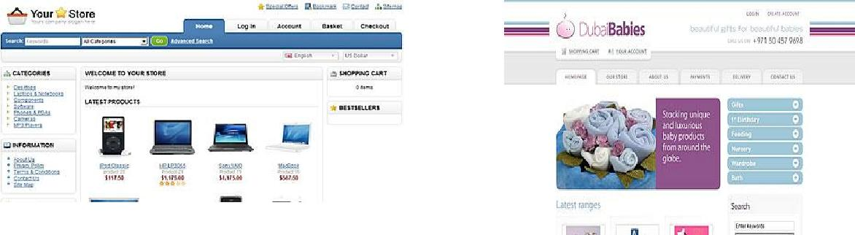

Default Template Custom Template

1. Multi-Language
2. Multi-Currency
3. Product Reviews
4. Product Ratings
5. Downloadable Products
6. Automatic Image Resizing
7. Multiple Tax Rates; to setup multiple tax zones so that the correct taxes are paid depending on which country the goods are going to be paid from or shipped to.

**13**

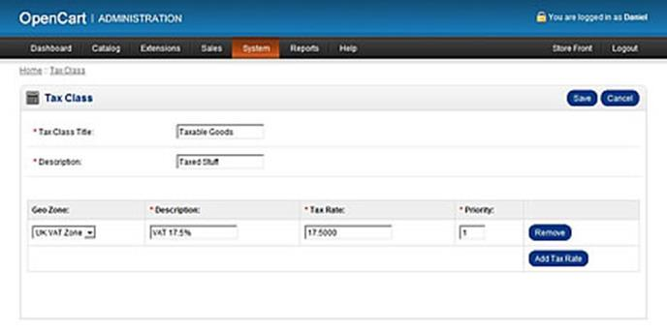

1. Bestsellers; This modification allows you to specify the time frame that your bestsellers show up for as well as a title for the module on your store front, giving you more flexibility should you require it. For example, if you want to show the best sellers for the last week, you would set the time frame to 7 and the title to "This week’s best sellers". This mod also automatically hides the module if there are no bestsellers, instead of showing a collapsed box with nothing in like the default one
2. Featured; to feature your products and select a banner image for each product you feature. You will be able to feature your products with a more attractive banner with much more information that just featuring the default product image.
3. Latest; to display latest products from different categories and display them in separate panels with its own category title.
4. Specials; to display special products.
5. Related Products
6. Unlimited Information Pages
7. Shipping Weight Calculation
8. Discount Coupon System
9. Search Engine Optimization (SEO)
10. Unlimited Module Instance System
11. Backup & Restore Tools
12. Printable Invoices
13. Sales Reports; OpenCart provides basically 3 different types of reports. More reports can be downloaded from the additional extensions.
    1. Sales Report, Calculate the total amount of sales by day, week or month.
    2. Products Viewed, View which products have been viewed the most or had the most interest from your visitors.

**14**

* 1. Products Purchased, View which products have been sold the most so you can better plan marketing campaigns to boost sales.

1. Google Analytics; to retrieve and display Google Analytics data. It makes very easy to collect, group and display metrics straight on your opencart admin section.



1. *Cart; to display the shopping cart anywhere in your website.* 
   1. *Cart module is fully responsive.*
   2. *Cart module is compatible with any theme, it automatically uses your* theme style.
   3. The shopping cart can be configured with three different "Add to cart" animations: "fly to cart", "Cart shake" and "Cart blink.;"
   4. An option allows to display/hide image products.
   5. The "Auto hide" feature allows to show the cart content only when the mouse hovers the cart total (which is always visible). When this option is disabled the cart content is always visible.
   6. The shopping cart content expands by a slide left/right/down effect. The module automatically detects its position and selects the right sliding direction.
2. Error Logging

**15**

**VI. Scope of Work**

1. **Website Design**

As it described in the section named “The Project Process” below, two design versions will be provided according to the negotiations with Balloony Land during the requirement gathering phase. This phase will terminated when Balloony Land selects the final design frame.

1. **Website Developing**

The proposed e-commerce system will be designed and developed on the top of OpenCart e-commerce platform in .php framework. This software provides the basic services needed for an e-commerce system. Further customizations are to be performed by Mawaqaa team to ensure the delivery of the required functionalities.

To achieve the full functionality of the required system an additional extension called “Multiseller / Multivendor Advanced Pro” must be purchased and implemented.



This extension provides the following features:

1. Register / Login seller account from frontend. Different seller panel
2. Start uploading category, products, and options from seller panel
3. Product different seller prices
4. Different folder for every seller for images
5. Seller can change status of order.
6. Seller module call on any page where you can view list of sellers.
7. Seller profile page where customer can see products by vendor.
8. Ajax uploading of images
9. Seller payment options PayPal, bank transfer, Cheque payment

**16**

1. Physical and downloadable product option for seller
2. Every seller registration, product, category approval option from admin
3. Product enquiry to seller on product page
4. After creating products, categories it will go to admin for approval
5. Admin also can login into seller account from backend using login seller link
6. Admin can add/assign product to seller from backend
7. In seller transaction history option to pay seller by PayPal, manual payment option
8. Check seller's transaction, products against that transactions and who bought those products in 1 page using jQuery
9. Products Bulk Uploading
10. Bulk Uploading images using Ajax
11. Membership Plans
12. Advanced Dashboard
13. Adaptive PayPal also supports for that you can contact us on skype.

|  |  |  |  |  |
| --- | --- | --- | --- | --- |
|  | **Website Features:** | | | |
|  | A system with following features will be developed to fulfill the | | | |
|  | customer requirements mentioned in sections above: | | | |
|  |  |  |  |  |
| **#** |  |  | **Feature** |  |
| **1** |  |  | Multiseller - Multivendor E-Commerce System |  |
| **2** |  |  | English & Arabic | |
| **3** |  |  | Responsive to work on latest mobile devices |  |
| **4** |  |  | Payment gateway –Knet, Master & Visa Cards | |
| **5** |  |  | Registered account for each seller |  |
| **6** |  |  | Each seller can upload its products and product’s details | |
| **7** |  |  | The admin will be able to set a fix service rate for each seller |  |
| **8** |  |  | The admin can set a fixed amount for delivery of each order | |
| **9** |  |  | Per each order session, the customers can buy from one seller only, |  |
|  |  |  | so products from other sellers will be issued in separated order |  |
|  |  |  | sessions with separated payment transactions. |  |
| **10** |  |  | All Payments going to the Website owner’s bank account. | |
| **11** |  |  | User registration |  |
| **12** |  |  | Customers can see their order and payment histories | |
| **13** |  |  | Sellers can see financial reports over the purchased items within |  |
|  |  |  | defined time intervals. |  |
| **14** |  |  | Customized financial reports for the admin | |

**17**

1. **Online Payment INTEGRATION**

For the integration with a payment gateway such as KNET/ Master & Visa Cards, there are some tasks to be performed at client side. The whole process starts when the client raise a Merchant Nomination via its Bank to KNET. Then KNET will require the client to complete a Merchant Questionnaire Form and return it.

The client must also make sure that following minimum technical requirements are available:

Secured web/application server. The merchant must acquire a certificate from a certificate authority in order to do e-commerce transactions with

Knet’s payment gateway. Knet server will receive transactions only from SSL certified web servers. Knet is currently running with Verisign 3.0 SSL certificate. It is the merchant’s responsibility to contact an authorized certificate authority and purchase its own certificate. Knet only accept the following SSL certificate issuers:

[**www.Verisign.co**](http://www.verisign.com/)**m**  [**www.Thawte.co**](http://www.thawte.com/)**m**

[**www.geotrusteurope.co**](http://www.geotrusteurope.com/)**m**  [**www.Equifax.co**](http://www.equifax.com/)**m**

Knet Payment Gateway server must import the Merchant’s SSL certificate using the keytool utility from JDK.

Based on the Merchant application server Knet will provide the appropriate plug-in needed to be used on the merchant site. KNET can support ASP, .NET, JAVA and Cold Fusion platforms and the client will also be provided with appropriate configuration’s manual. The provided

API will contain:

A configuration file which is unique for connection with client’s

Bank Account. Sample code

**18**

API dll.

According to KNET provided API the application will open a web view for filling KNET credentials.

The whole payment process starts when the user presses the “Pay Now” button of the payment page. The event payment is instantiated and its variables are initialized. This is also the time where the payment details are saved in the database and/or text log file. A procedure is then called to start with the authentication process, which is the first process in the payment transaction.

This procedure will return a value, which will identify if the transaction is authenticated or not. Again, the result is to be recorded, by updating the database and/or text log file. If the authentication is successful, the user is to be redirected to the Payment Gateway site where the user is to enter the ATM account credentials to be used for purchasing. Once the user’s credentials are validated and the transaction is done, the user is forwarded back to the response page, which captures the result of the payment transaction that is sent by the Payment Gateway site. Records of the payment are updated and then the user is again forwarded to the receipt page. The user should also receive an email containing the same details as the receipt page. In case an error is encountered, the user forwarded to an error page, which updates the payment records with the error information.

1. **Delivery Email Service:**

After each completed payment transaction the system will send an email to the seller (Cooperative Society) contains the details of the order and the purchased items.

The seller will see a ‘’Pending Order” List. When the seller confirm the order it will moved to completed order list and an email will go to the

Delivery Officer at the website’s owner organization with following details:

Order Number List of Items

**19**

Name of Seller (Cooperative Society) Address of Seller (Cooperative Society) Name of customer

Address of customer

1. **Admin’s Financial Reports**

In order to manage the system the admin can see two types of financial reports:

Purchases list of each seller within a defined time interval. The list will show Total Purchase Amount, Defined Service Rate, Total Service Amount and The Amount Transfer Date which is edited by the admin manually.

List of orders sent to the delivery officer within a specific date interval categorized by sellers. The list will display The Total Amount of each order and The Delivery Amount.

1. **Event Calendar**

This package implements the typical Events view functionality in a simple and easy way. The events are presented to the viewer as a list with a short description and the dates. You can choose how many events to show on the list at the same time as well as whether to show the current and coming events or past events. By clicking the link in the event's title, the viewer can see the detailed information of the event.

1. **Live Support**

Live Support is live customer support software for your web site that enables visitors to instantaneously communicate with your customer service personnel. Web site visitors simply click a Live Support button and are connected with one of your customer service representatives. Your company

**20**

representative then assists the visitor by providing information, links, graphics, or even guiding them through your web site.

**FEATURES AND BENEFITS**

What makes Live Support stand out of the crowd when it comes to choosing a live customer support software for your web site?, Aside from its powerful features and ease to use, here are some of the top reasons that make the Live Support your best choice for deliver live customer service directly on your web site:

**Support for multiple requests and chats at the same time:** Yourrepresentatives can hold on-line chats with multiple users at the same time.

**Support for unlimited operators and departments:** Set as manyrepresentatives and departments as you need. Get your whole staff to work with the system; you don't need additional licenses per representative as with other similar applications.

**Party Is Typing Notification:** Use this feature to know when yourcounterpart is typing a message.

**Automatic transcript storage:** Set Live Support to log and save yourchat sessions for later review.

**Proactive Chat (Client Pull):** Invite your visitors to chat andproactively provide support. Pull clients and increase your sales.

**Visitor Tracking:** Track your site visitors in real-time, know who's onyour site and doing what and for how long. Now you can even track pages by department (set which department tracks which pages).

**Custom Invitations:** Imagine being able to prompt your visitors tochat by sending them an invitation about the page they're surfing!

**21**

Your visitors won't receive a generic "**Would you like to chat?**"

request, but a custom message about the page they're viewing.

**Pop-up Blocker Friendly:** Live Support is now pop-up blockerfriendly. The pop-ups will not be blocked by 3rd party applications.

**Hidden Departments:** You can have hidden departments onlyaccessible for your representatives. These departments can be used to escalate support issues. In this way you can have a frontline of support representatives which can select and filter the requests and pass them to the proper representatives.

**Automatic Reconnect:** Your live monitor can detect if the connectiongets lost and attempt to reconnect so that you do not lose any potential customers.

**Country Lookups:** Live Support can automatically detect the countrywhere your customer is located.

**Desktop Launcher Utility:** Live Support comes with an optional freeutility that you can install on your PC and gets connected to the system on Start Up. Better yet, the application hides in your system tray so it is readily available and displays messenger like notifications.

**Past conversations review:** Your representatives will be able toreview any chats that the user has had in the past. This is useful when a chat is transferred and the new assigned representative wants to know what kind of information was supplied.

**E-mail signature option:** Now you can embed the live support buttonon all your outgoing e-mails. Your customers can easily request support directly from their mailbox.

**22**

**Text Links Instead of graphic button:** You can set text links insteadof using a graphic support button.

**Instant Messenger System:** Built In Pager to send quick messages toother representatives online, a powerful feature to request help to other reps. while holding a chat session.

**Auto-Engage:** Now, you can set Live Support to automatically reachfor your customers if they spend a predefined time on a page. If a customer spends 2 minutes on a page, Live Support will immediately ask the user if she would like to talk one of your representatives

**Automatic Linking of URL's:** During a chat session, Live Support willautomatically convert any typed URL or e-mail address to a link.

**Transfer calls to other departments / operators:** Transfer calls to anydepartment or representative directly with just a click.

**Visitor Data Capture:** Your visitors IP address, host, browser,operating system and detailed information regarding past requests, is available to your representatives in their chat panel.

**Footsteps Tracking:** Easily review which pages have been visited bythe user and what is his current location.

**Independent Support Buttons for your departments and representatives:** Set different status icons for your departments andrepresentatives. Your customers can directly chat with your representatives or departments and instantly know the online status of each.

**Session Time Metrics:** Generate complete instant reports about thetotal and average session times for your representatives and departments.

**23**

**IP Filter:** Block any undesired calls and spammers by using the built inIP filtering system

**Automatic Purging of Chat Transcripts:** You can set the system toautomatically remove older session transcripts in order to keep your database working fast

**Busy Requests Reporting:** Get immediate information on requeststhat were not accepted. Check who declined the call and how busy the representative was at that time

**Support for Representatives Photo:** Display your representative’sphotograph to your customers to provide an additional human touch to your support sessions

**Push Pages and files:** Send your visitors directly to the pages they’relooking for send them files and maximize your customer's experience.

**Canned Responses and Commands:** Add any number of automatedreplies and commands, push images, messages and URL's by just selecting the command from a list box!

**Quick Words:** Easily trigger canned commands and automatedreplies by just typing a single word. A Quick Word is a shortcut to your canned commands, once typed it'll trigger the complete canned command.

**Sound Alerts and Notifications:** Live Support can play sound alerts tonotify you when a request call has been placed or when a user has replied during a chat session or even when a new visitor is detected on the site.

**24**

**Live Monitor:** Web-based live monitor to check your incomingrequests. Also an optional Windows utility is included that connects to the system every time you start your PC.

**Request Balancing:** Live Support automatically balances your calls toevenly distribute them among your on-line representatives per department! , additionally you can set how many requests each of your users can handle.

**Automatic Re-queue of request:** If no one takes a call, the requestcan then be queued again so that any free representative can take it

**Automatic request handling:** If after a selected time period the call isnot taken by the representative (she's not at her desk for example), the call will be immediately queued again and assigned to another representative.

**E-mail Chat Transcript:** Users can get a copy of the chat transcript bye-mail with just a click.

**Printable Transcripts:** Users can get printable versions of the chattranscripts with just a click.

**Leave a message:** If customers can't reach you (your whole staff isbusy or off-line) Live Support will prompt the customer to leave you a message!

**Option to rate the request session:** Your customers can rate thesupport session at any time during the chat, plus your representative gets immediate feedback on how he is doing!

**Comprehensive Stats and reports:** Graphic charts and reports let yousee exactly the number of requests per day, requests per department, system performance, and more!

**25**

**Optional Form Fields:** You can have up to 3 custom fields to gatherinformation related to your business just before the customer submits his chat request.

**Hot Lead Tracking:** Live Support can now identify users with a highpurchase potential. Using its Hot Lead tracking technology, your service representatives will be able to identify and pick qualified leads browsing your site based on their referral.

**Representative Login Times:** Get a detailed view of the times yourrepresentatives connect and disconnect to the system.

**Active Sessions Report:** Get a quick view of which sessions are takingplace by checking a report in the start screen.

**Button code generator:** Generate codes for displaying support buttons that connectthe users directly with your departments or representatives, that can be embedded on e-mails or that bypass the contact form.

**26**

**VII. Project Execution Approach**

Below illustrated figures describes the project execution approach for Website Development for Customer-

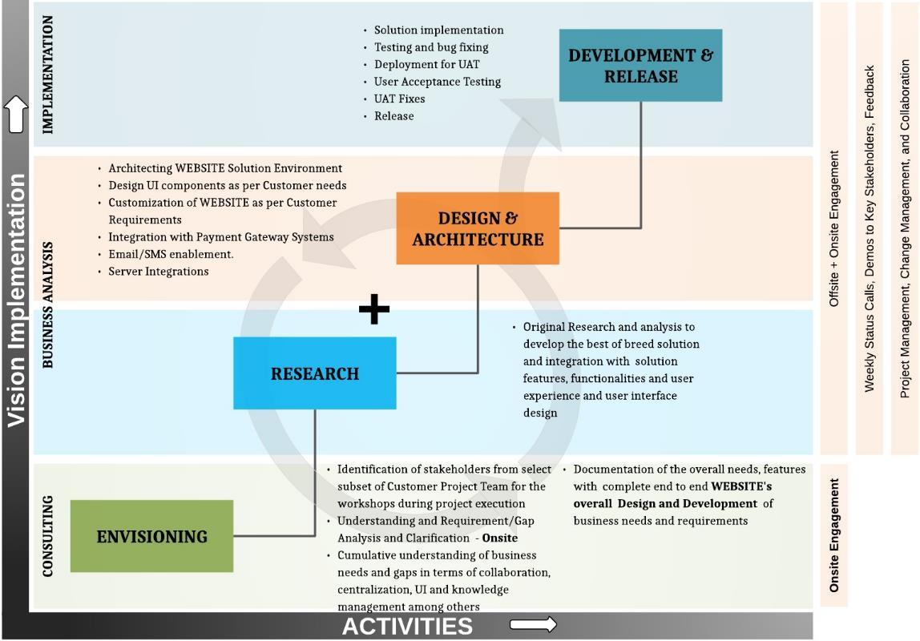

**27**

VIII. **The project process**

1. Project manager will be assign with the team after signing the agreement
2. Phase I – Requirement Gathering and site structure approval
   * 1. Kickoff meeting to collect the requirements
     2. The output of this kickoff meeting will be :
        1. Website structure for client review and approval
        2. Project Timeline
3. Phase II – Website Design
   * 1. Meeting will be held for collecting design related requirements and discussing some ideas
     2. Submit the designs layout (Home page and inner page layout) for client feedback and approval
     3. Based on client feedback we either:
        1. Approval the selected design and proceed with next phase
        2. Combine elements from both designs to come up with final version
        3. Change the whole design and coming up with new one, and for that we need to define the reason for that to ensure proper implementation.
     4. After finalizing the client comments and feedback, client need to submit official design approval
4. Phase III – Project implementation
   * 1. Based on client approval for the design, website master templates will be created
     2. System and Add-s on will be installed and configured
     3. Template integrated with the systems
     4. Site structure will be built and content will be added
     5. Emails information will be requested for activating the forms
     6. Website QA/QC
     7. Client Approval
5. Phase IV – Launching website online
   1. Hosting and domain name need to be ready to launch the site online
6. Phase V – Training : training will be given as per the tools in the package

**28**

**IX. Hardware Specification details**

1. Default Server requirements, your server should cover and include everything as its mention below (in more details).

Hardware Recommendation:

* Single Quad Core Intel® Xeon® Processor E2-1240 v3
* 3.4 GHz, 10 MB Cache (w H/T)
* 8 GB DDR3 RAM
* x 500 GB SATA Drives, RAID 1
* Hardware RAID Controller
* 10 TB per month Bandwidth
* 1000 Mb Port Speed
* 3IPs

Supported Operating Systems:

* Linux x86, x86-64 Supported Web Servers:
* Apache 1.3.x
* Apache 2.0.x
* Apache 2.2.x Supported Browsers:
* Microsoft Internet Explorer 7 and later
* Mozilla Firefox 3.5 and later
* Apple Safari 5 and later on Mac only
* Google Chrome 7 and later
* Adobe Flash browser plug-in should be installed

**29**

PHP Compatibility:

* PHP 5.4 is supported natively by EE 1.14 and later and by CE 1.9 and later
* Earlier CE and EE versions support 5.2.13 - 5.3.24; or 5.4.x with a patch for CE or EE (the patch is listed as PHP 5.4 Compatibility in the EE support portal)
* Required extensions:

PDO_MySQL simplexml

mcrypt hash

GD DOM

iconv curl

SOAP (if Webservices API is to be used)

* Safe_mode off
* Memory_limit no less than 256Mb (preferably 512), if it is “16M” then it will be a great.

MySQL:

* EE 1.13.0.0 or later: MySQL 5.0.2 or later
* EE 1.12.0.2 or earlier: MySQL 4.1.20 or later
* CE (all versions): MySQL 4.1.20 or later

SSL:

• A valid security certificate is required to work over a secure channel (HTTPS) from payment gateways.

Server - hosting - setup:

* Ability to run scheduled jobs (crontab) with PHP 5
* Ability to override options in .htaccess files

SSH Access:-

**30**

We need SSH full access control on the particular server for install PHP and Apache settings can be controlled by the same SSH access.

Note: - The hosting server should not be a shared server at least a VPS server.

**31**

**X. System Development Life Cycle (SDLC) Process**

|  |  |  |  |  |  |  |  |  |  |  |  |
| --- | --- | --- | --- | --- | --- | --- | --- | --- | --- | --- | --- |
|  | **SDLC** |  |  | **Service/Deliverable** | | |  |  | **Deliverable Description** |  |  |
|  | **Phase** |  |  | **Name** |  |  |  |  |  |  |  |
|  |  | |  |  | |  |  |  |  | |  |
|  | **Requirement** |  |  | Delivery 1 – Business | |  |  |  | This document elaborates on the requirement of |  |  |
|  | **Analysis** |  |  | Requirement document | | |  |  | Customer. This is a contract between Customer |  |  |
|  |  |  |  | TYPE: Document | |  |  |  | and the team, describing functionally what |  |  |
|  |  |  |  |  |  |  |  |  | Customer expects. The completeness and |  |  |
|  |  |  |  |  |  |  |  |  | correctness has to be verified by Customer and |  |  |
|  |  |  |  |  |  |  |  |  | the document has to be signed off as it |  |  |
|  |  |  |  |  |  |  |  |  | significantly impacts the quality of the |  |  |
|  |  |  |  |  |  |  |  |  | development activities and all follow on phases. |  |  |
|  |  | |  |  |  |  | |  |  |  |  |
|  | **Analysis and** | |  | Delivery | 2 | –Analysis | |  | Mawaqaa will analyze and develop the application | |  |
|  | **Development** | |  | document |  |  |  |  | using reusable components. | |  |
|  |  |  |  | TYPE: Document | |  |  |  |  |  |  |
|  |  |  |  |  | | | |  |  | |  |
|  |  |  |  | Delivery 3 - Detail Project | | |  |  | This document includes all of the high level |  |  |
|  |  |  |  | Plan |  |  |  |  | project details, deliverables and schedules |  |  |
|  |  |  |  | TYPE: Document | |  |  |  | including the release date. Often, the team will |  |  |
|  |  |  |  |  |  |  |  |  |  |  |
|  |  |  |  |  |  |  |  |  | modify the project plan to meet a required |  |  |
|  |  |  |  |  |  |  |  |  | release date. Although features, resources, and |  |  |
|  |  |  |  |  |  |  |  |  | release date may vary, a fixed release date will |  |  |
|  |  |  |  |  |  |  |  |  | cause the team to prioritize features, assess risks, |  |  |
|  |  |  |  |  |  |  |  |  | and plan adequately. |  |  |
|  |  |  |  |  | |  |  |  |  |  |  |
|  |  |  |  | Delivery 4 – UAT | |  |  |  | This document contains the test cases with the | |  |
|  |  |  |  | Specifications | |  |  |  | detailed steps to follow during the test process in | |  |
|  |  |  |  | TYPE: Document | |  |  |  | the application testing phase. The same | |  |
|  |  |  |  |  |  |  |  |  |  |
|  |  |  |  |  |  |  |  |  | document will be referred during UAT. This is the | |  |
|  |  |  |  |  |  |  |  |  | responsibility of Customer. | |  |
|  |  |  |  |  | |  |  |  |  | |  |
|  |  |  |  | Delivery 5 - Setup | |  |  |  | This is the deployment of the Development |  |  |
|  |  |  |  | Development Environment | | |  |  | Environment server and the tools to manage the |  |  |
|  |  |  |  | TYPE: Work |  |  |  |  | code library. The Development environment will |  |  |
|  |  |  |  |  |  |  |  |  | be set up for the offsite work related to |  |  |
|  |  |  |  |  |  |  |  |  | integration with the existing systems. |  |  |
|  |  |  |  |  |  |  |  |  |  |  |  |
|  | **Build** | |  | Delivery 6 - Application Final | | | |  | Development of the code and software | |  |
|  |  |  |  | Release |  |  |  |  | applications for the functionalities based on the | |  |
|  |  |  |  | TYPE: Work |  |  |  |  | Business Requirement, System Design and Project | |  |
|  |  |  |  |  |  |  |  |  |  |
|  |  |  |  |  |  |  |  |  | Plan. All this code is built in the development | |  |
|  |  |  |  |  |  |  |  |  |  |  |  |

**32**

|  |  |  |  |  |  |  |  |  |  |
| --- | --- | --- | --- | --- | --- | --- | --- | --- | --- |
|  |  |  |  |  |  |  | environment and the code repository is stored in | |  |
|  |  |  |  |  |  |  | the development environment. | |  |
|  |  |  |  |  |  |  |  |  |  |
|  | **Application** |  |  | Delivery 7 - Testing |  |  | This is the deployment of the Test environment |  |  |
|  | **Testing** |  |  | Environment Setup |  |  | that will support the testing of the functionality |  |  |
|  |  |  |  | TYPE: Work |  |  | and the integration of the framework tools. This |  |  |
|  |  |  |  |  |  |  |  |  |
|  |  |  |  |  |  |  | environment will be used for the testing of all the |  |  |
|  |  |  |  |  |  |  | installation, configuration and code |  |  |
|  |  |  |  |  |  |  |  |  |  |
|  |  |  |  | Delivery 8 - Functional | |  | The Functionality Testing of the applications and | |  |
|  |  |  |  | Testing | |  | usage functionality will be based on the BR | |  |
|  |  |  |  | TYPE: Work | |  | document and the UAT specifications | |  |
|  |  |  |  |  |  |  |  |
|  |  | |  |  | |  |  | |  |
|  | **UAT** |  |  | Delivery-9 UAT Support & |  |  | The process of acceptance of the solution by |  |  |
|  |  |  |  | defects fix Report |  |  | Customer |  |  |
|  |  |  |  | TYPE: Work & Document |  |  |  |  |  |
|  |  |  |  |  |  |  |  |  |  |
|  | **Deployment** | |  | Delivery-10 Application Code | |  | Application code, installation/ deployment | |  |
|  |  |  |  | with documentation | |  | manual. | |  |
|  |  |  |  | TYPE: Document | |  |  |  |  |
|  |  |  |  |  | |  |  | |  |
|  |  |  |  | Delivery-11 User Manual |  |  | User Manual for Admin and Business Users. |  |  |
|  |  |  |  |  |  |  |  |  |  |
|  |  |  |  | Delivery 12 - Solution | |  | Deployment of the solution in the production | |  |
|  |  |  |  | Framework Deployment | |  | environment. | |  |
|  |  |  |  | TYPE: Work | |  |  |  |  |
|  |  |  |  | Delivery 13 - Final user |  |  | Quality assurance of the solution with the final |  |  |
|  |  |  |  | acceptance |  |  | acceptance by Customer team. |  |  |
|  |  |  |  | TYPE: Work |  |  |  |  |  |
|  | **End User** | |  | Delivery 14 - System Training | |  | The training to Customer technical team as well | |  |
|  | **training** | |  | TYPE: Work | |  | as the operations team for effective usage of the | |  |
|  |  |  |  |  |  |  | Solution. This will be done by Customer Key users. | |  |
|  |  | |  |  | |  |  | |  |
|  | **Stabilization** |  |  | Delivery 15- W Stabilization |  |  | Provide Stabilization Support on the application |  |  |
|  | **Support and** |  |  | Support on the Deployed |  |  | and deployment for an agreed period after going |  |  |
|  | **Maintenance** |  |  | system |  |  | live. |  |  |
|  |  |  | TYPE: Work |  |  |  |  |
|  |  |  |  |  |  |  |  |  |
|  |  |  |  |  |  |  |  |  |  |

**33**

XI. KEY ASSUMPTIONS

1. All documentations that will be created for this project is available in hard copy and electronic format
2. Any modifications to the scope of work will be handled through a change control process and will be agreed by both parties
3. An authorized representative of project owner will be available in the time of completion of the build phase so that all documentation can be accepted and signed.
4. All changes to schedule or technical requirements must be provided to MAWAQAA in written format. Email is considered as written format and receipt of correspondence should be provided.
5. Balloony Land had accepted the costs/time estimate detailed in the proposal.
6. Balloony Land had accepted the standard terms and conditions detailed in the proposal.
7. Proper development will only start after all pre-development documentations and graphic interface templates has been approved.
8. Screenshots provided in this document is for reference only and application interface elements might change to enhance the look and feel of the application
9. Solution will NOT support legacy browsers (such as IE8 and below) and any browsers which has support revoked from the creators.
10. All our prices are in KWD.
11. The proposal will be accepted in total and is not divisible. Costing is calculated on size and scope. If the scope and size changes, the billing will be re-adjusted.
12. The validity of this proposal is 15 days from submittal.
13. Any deliverable submitted for acceptance will be deemed accepted if MAWAQAA did not receive any official rejection or feedback within three working days from the submittal date.
14. Resources will have access to Balloony Land premises.
15. All communication will be made through MAWAQAA project manager.

**34**

1. All required documentation requested by MAWAQAA or the project team should be made available.
2. Customer will have resources available to assist the consultant in his activities and provide access to relevant systems and information.
3. Customer will allocate the required office space for MAWAQAA team equipped with telephone line and Internet connection.
4. Implementation of the solution to be done in Kuwait, additional fees will be added if implementation to be in other country.
5. Additional services outside the scope will be evaluated and priced on a separate work order. Pricing will be mutually agreed upon between Balloony Land and MAWAQAA at the required time.
6. If required- Access to the existing database will be granted with administration privileges
7. If required -Access to the new hardware will be granted with administration privileges
8. This time line is based on Balloony Land request to increase the resources, and will be applicable only after official request is made by Balloony Land Team and approved by Mawaqaa.
9. Government & Public holidays are not currently counted in this timeline

**Dependencies**

The successful implementation of the proposed solution is dependent upon:

Documents approval within 3 business days of submittal.

Any new change request during the implementation phase.

**Risks**

The risks involved in the implementation of the proposed solution are:

* Deadlines affected by complexity of tasks.

**35**

* Omitting content migration due to oversight
* Time Lines effected by large disparate content migration.
* Additional project risks will be identified as necessary.
* Documents approval within 3 business days of submittal.

**36**

**XII. RESPONSIBILITIES**

**1.1.1.** **Responsibilities**



**Mawaqaa**



Design conceptualization and template creation

Installation of the proposed solution



Integration of the proposed solution with the design templates

Support for proposed solution

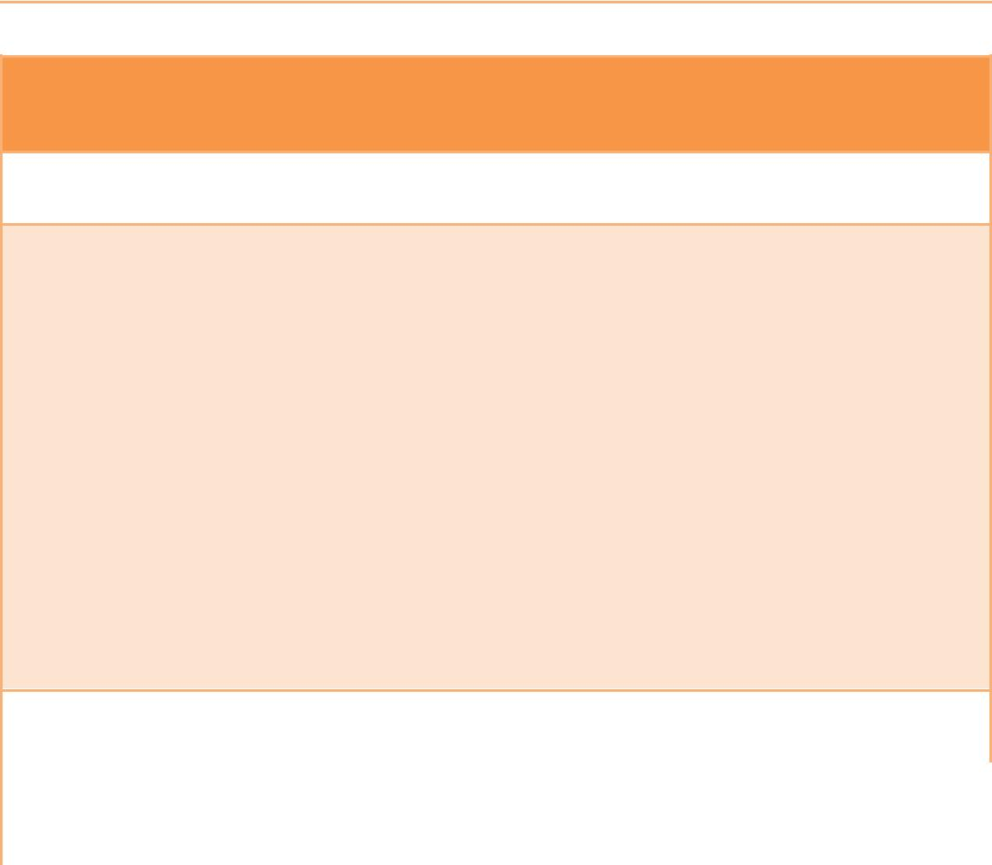

**Balloony Land**

Signing approval of all documents, designs and templates submitted

Installation and renewal Application server(s) setup which includes the following

1. Network Setup.
2. Server Purchase, Operating System and Web Server Installation, Setup, Administration and Maintenance
3. Database System License Purchasing, Installation, Administration and Maintenance.
4. Domain Name Registration and Pointing to the said server as well as renewal.
5. Mail account setup and maintenance for the application sender account as well as all recipient accounts.

Application Physical File and Database Backup



Arrangement of all 3rd Party API needed for development (Payment Gateway etc.)

**37**

1. **Tracking Project**

Mawaqaa using a very efficient tool “ Basecamp Project Management tool” that allow both parties to track all project implementation phases, accounts will be created for all Mawaqaa teams who will work on Balloony Land project and Balloony Land teams who are responsible of managing the project during the implementation phase .

Any change request on the project during the implementation time will be submitted though an official form and a subject for evaluation.

1. **Testing Approach**

Testing will be applied during the whole project implementation phases and cover the following points:

* Functionality Testing
* Design testing
* Website usability testing
* Use cases testing

Unit Testing – Unit testing will be performed for each completed major milestones by the assigned Developer.

Integration Testing – QA specialists will be assigned to test the integrated solution after the full integration process in a test environment.

Solution Testing – Once the integration is done, the system will then be tested as a whole as per the requirements provided earlier by the client.

**38**

XIII. PROJECT PLAN & TIME ESTIMATE



**Project Activities & Tasks**

**PROJECT INITIAL AGREEMENT**

1. Requirements Gathering
2. Proposal Agreement (Approval)

**Balloony Land will be assigned a Project Management Team from Mawaqaa handling all the project activities**

**Preliminary Activities**

1. Requirements Gathering Completion Process
2. Requirements Analysis Process
3. Site Structure Definition Process
4. Site Structure Approval

**Preliminary Layout Design Activities (Concept Design)**

1. Home Page Layout Design Process
2. Inner Page Layout Design Process
3. Layout Submission and Client Evaluation

**Site Templates Design Activities**

1. Template Design Enhancements
2. Image / Graphics Enhancement
3. Interactive animated Components Enhancements (Intro, Banner, Etc…)
4. SRS Completion (Software Requirement Specifications: contains Functional requirements, Non-Functional requirements, All HTML design pages, Database Design and Table relations)
5. SRS Approval by Client

**39**

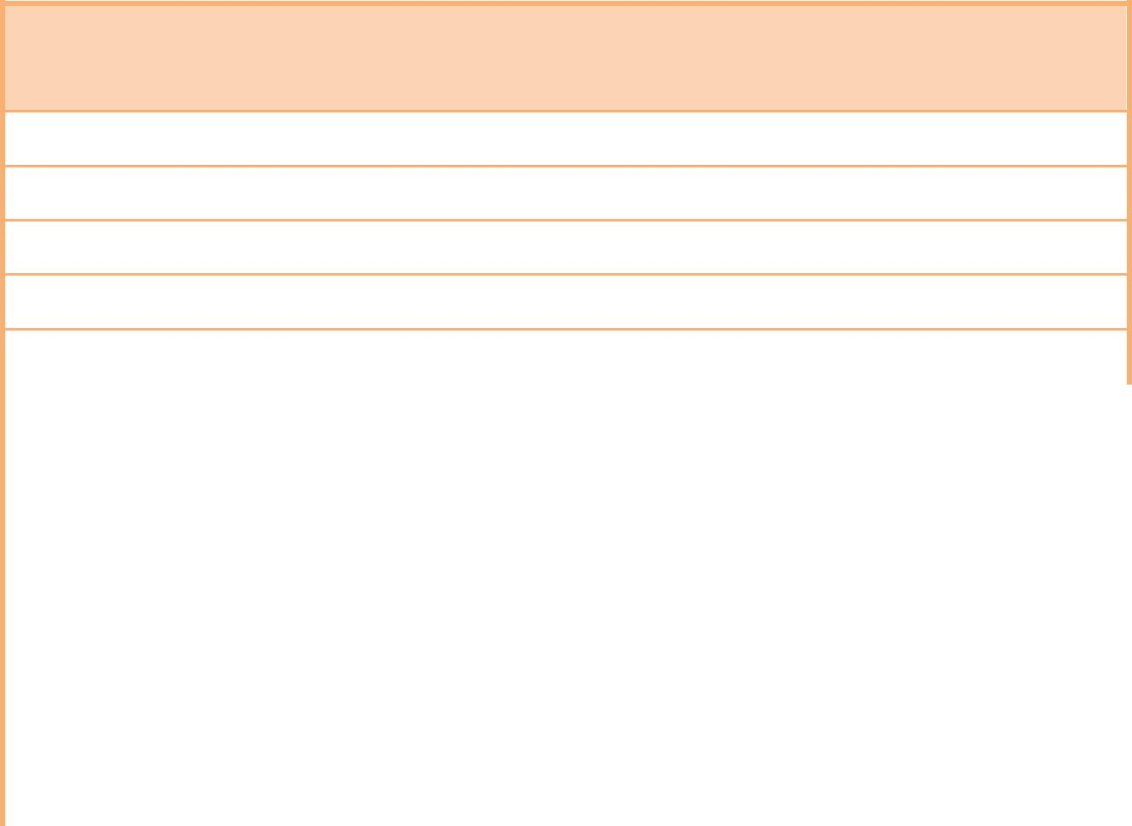

**System Development and Integration Processes**

1. Set up of E-Commerce System
2. Website development
3. Set up of Multiseller / Multivendor Extension
4. Set up of Email Gateway
5. Delivery Email Service Development
6. Reports Module Development
7. Usability Testing

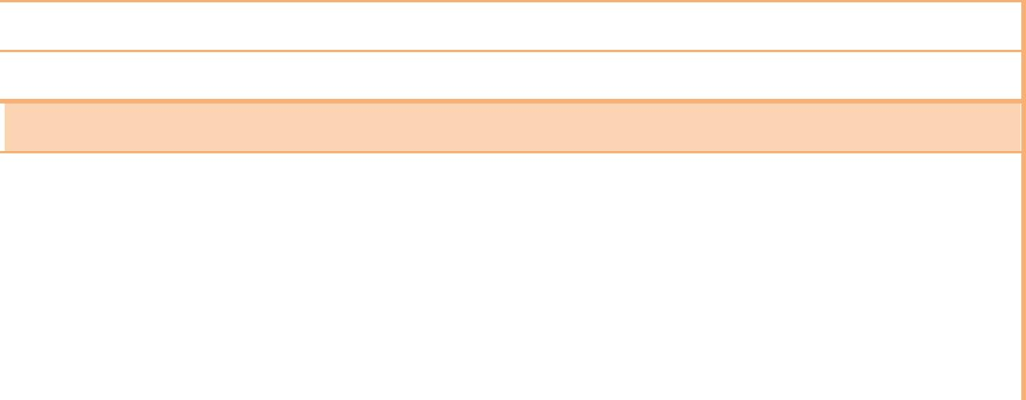

**Deployment & Testing**

1. System Deployment
2. Client Testing & Approval
3. Launching the system



**End-Users Training**

1. Content Management System (CMS)

**40**

**XIV. PROJECT COST**

|  |  |  |  |  |  |  |
| --- | --- | --- | --- | --- | --- | --- |
|  | **SERVICES** | |  | **COST / Kuwait Dinar** |  |  |
|  |  |  |  |
|  |  |  |  |  |  |  |
|  | **1-** | **Responsive E-Commerce Website Design (Arabic &** |  |  |  |  |
|  |  | **English) including:** |  |  |  |  |
|  |  | Email Notification Integration |  |  |  |  |
|  |  | SMS Notification Integration |  |  |  |  |
|  |  | Event / Calendar Module |  |  |  |  |
|  |  | Live Support Module |  |  |  |  |
|  |  | Payment Gateway Integration |  |  |  |  |
|  |  | Social Media Integration |  |  |  |  |
|  |  | 3 Months Warranty |  |  |  |  |
|  |  | User Training |  |  |  |  |
|  | **2-** | **Designing and building mobile application for the** |  |  |  |  |
|  |  | **following:** |  |  |  |  |
|  | Native Apps - iPhone (iOS 6 and above) | |  |  |  |  |
|  | Native Apps – Android (Android 4.0 and above) | |  |  |  |  |
|  | **3-** | **1 Year Maintenance and Support as per the Appendix** |  |  |  |  |
|  |  | **below** |  |  |  |  |
|  |  |  |  |  | |  |
|  |  |  |  |  |  |  |
|  |  |  |  |  |  |  |

**41**

**XV. TERMS AND CONDITIONS**

**Confidentiality and Copyright**

All the information contained in this proposal is confidential, commercial in nature, subject to contract, and is submitted by Mawaqaa™ National Web Solutions under a condition or understanding that only the Client’s official staff will use it.

**Duration**

This proposal will remain valid for a period of **30** days from the date of the proposal.

**Payment Method**

* **First Payment** – **60%** to be paid upon the signing of an officialagreement.
* **Second Payment** – **20%** to be paid upon approval of JPG formatDesign.
* **Final Payment** – **20%** to be paid After signing the Closure Letter

Content must be provided in a digital format Only (CD-ROM, flash Memory or external Drive). Mawaqaa will not accept any hard copies of content that requires to be manually typed by the designers.

Required hardware (servers), third-party products (software components), and third-party services stated above – if required, will be client’s responsibility. Cost and licensing fees for this products or services will be handled by the client.

**42**

**XVI. APPENDIX 1**

1. **AGREEMENT OVERVIEW**

This represents Support Service Agreement between Mawaqaa and Balloony Land for the provisioning of the services as stated in this proposal, for the Balloony Land’s website.

This Agreement outlines the parameters of the services covered as they are mutually understood by both parties.

Whereas the Mawaqaa is engaged in design, operation and management of websites and have the qualifications and the experience to create, develop, maintain and support a website which can fulfill the Balloony Land’s needs, and the Balloony Land is a company that has an agreement with Mawaqaa to build their E-commerce Website and Mobile Applications (IOS & Android) desires to have it supported through this agreement and whereas both parties are fully competent to enter into this agreement.

1. **SUPPORT ACCESS AND RESPONSE** 
   1. We provide access to support as follows:

**Help Desk & Phone Support**: Available 5 days a week Sunday toThursday (08:00 to 16:30)

**Email support**: Available 5 days a week Sunday to Thursday (08:00 to16:30)

**Support ticket system**: A 24 hours web based system, which willgenerate a unique ticket number for each case. A username and password will be provided once this agreement has been signed.

* 1. We aim to respond to all support requests within 8 hours on weekdays. Response times may vary depending on the Level of the support ticket and current support request volumes.

**43**

1. **LEVELS OF SUPPORT**

There are three levels of support provided under this agreement. These levels, which are integrated into the Mawaqaa’s support process, are defined as follows:

1. **Level 1**—This support is provided by the appropriate Mawaqaa help deskagent when they receive the Support Request from the client.

This level represents generalist support. If this level of support cannot resolve the problem, the Support Request is passed to the Mawaqaa’s Level 2 supports agent.

1. **Level 2**—This support is provided by the Mawaqaa’s InfrastructureSupport or subject matter Specialist. This level of support does not perform code modifications. Operational issues will be resolved at this level. If resolution requires code modification, the Support Request is passed to Mawaqaa’s Level 3 support agent
2. **Level 3**—This support is provided by the Mawaqaa’s application supportspecialist. This level of support performs code modifications, if required to resolve the problem.
3. **SCOPE OF WORK**

This Support Service Agreement covers only the E-commerce Website and Mobile Applications (IOS & Android), its features and functionality that have been created by Mawaqaa.

1. **SUPPORT SERVICES**

The following services are provided in response to the Support request raised by the Balloony Land.

For the purposes of this agreement, a Support request is a request for support to fix a bug, or defect in existing application code or a request for support that involves no modifications to application code.

**44**

1. Corrective Support—Defined as activities associated with root-cause analysis and bug-fix isolation and resolution:

Root-cause analysis—Analysis of the root causes of problems. Problems will be reviewed to determine their root causes, measures will be taken to correct the source of the problems, and reports will be prepared and distributed in a timely fashion.

Bug fixes—defined as the emergency repair of any website system operation that does not comply with the current signed and approved website system specification. This includes website system errors, "hung" or halted screens, or unexpected results within the website system that render it unusable for the purpose for which it was designed. However bug fixes are restricted to the applications created by the Mawaqaa

Partner Support – If Mawaqaa is unable to resolve a programming issue for a Third party solution that has been

utilized by the Mawaqaa on the Balloony Land’s application, then the Mawaqaa will escalate the issue to the Third Party and will try and arrive at a solution.

If the Balloony Land’s website is hosted on the Mawaqaa’s servers then the Mawaqaa will make a backup once a month of the website and database and will assist in recovery of the website if it goes down for any reason.

If the website is hosted on the Balloony Land’s server or with any other Third Party, then Mawaqaa will not be responsible for making any backup, it will be the sole responsibility of the Balloony Land to maintain the backup of the website and databases etc.

**45**

1. **REQUESTS FOR SUPPORT SERVICES NOT COVERED UNDER THIS**

**AGREEMENT**

This agreement does not cover the following requests. If the Balloony Land requires any of the following services, there will be a charge on a case by case basis (or) it will be covered under the terms and conditions of a separate contract.

1. Any new development, website enhancements, new or added interface, Intranet “front ends” to existing systems, new functions and customization, creating of complex forms, new report generations, Re-design of website, or any elements, restructuring of the websites entire navigation system, creating new logos.
2. Support for third party application provided by the Balloony Land for use on their system. Support for any code or database modification or corruptions, conducted or created by Balloony Land or any other party other than the Mawaqaa.
3. If the website is hosted on the Balloony Land’s server or any other third party hosting, then Mawaqaa will not be responsible for making any backup, and maintaining security of the servers from hacking attacks and security breaches.
   1. Updating the website content such as text, information, images or any other content.
4. **VALIDITY & RENEWAL**

The validity period for this agreement is **1 year from the date of launching the** **website.**

This Agreement is automatically renewed after the validity is expired if not cancelled in writing 2 months prior to its expiry.

If the Balloony Land does not wish to renew this Agreement, then the Mawaqaa will not be liable for any issues that arise in the website after the expiry date.

If at any later date the Balloony Land wants to renew the Support Agreement with the Mawaqaa, then the Balloony Land would require paying the Mawaqaa for the period from expiry date of this Agreement to the signing date of the new Agreement.

**46**

1. **TERMINATION OF AGREEMENT**

During the agreement validity period both parties have the right to terminate this agreement by sending a 2 months written notice to either party declaring its intension to terminate the agreement.

**1.10. AMENDMENT TO AGREEMENT**

Any amendment to the Terms and Conditions of this agreement would require the approval of both signatories of the agreement; this amendment would be part of the agreement.

1. **APPLICATIONS COVERED**

This Support Service Agreement (Article 4 & 5) covers the websites and related applications that are created and implemented by the Mawaqaa only.

**1.12. BALLOONY LAND RESPONSIBILITIES**

The Balloony Land assures the Mawaqaa and unconditionally guarantees that any elements of text, graphics, applications, codes, software, photos, designs, trademarks, or other artwork furnished to the Mawaqaa for inclusion in the Balloony Land’s web site are owned by the Balloony Land’s, or that the Balloony Land has permission from the rightful owner to use each of these elements, and will hold harmless, protect, and defend the Mawaqaa and its subcontractors from any claim or suit arising from the use of such elements furnished by the Balloony Land.

**1.13. CONFIDENTIALITY**

The parties agree to hold each other's Proprietary or Confidential Information in strict confidence. "Proprietary or Confidential Information" shall include, but is not limited to, written or oral contracts, trade secrets, know-how, business methods, business policies, memoranda, reports, records, computer retained information, notes, or financial information.

The parties agree not to make each other's Proprietary or Confidential Information available in any form to any third party or to use each other's Proprietary or

**47**

Confidential Information for any purpose other than as specified in this Agreement.

Each party's proprietary or confidential information shall remain the sole and exclusive property of that party. Confidential Information shall continue even after the expiry of the Contract.

**1.14. COMMUNICATION / NOTICES**

Any communication or notices required by this contract shall be given in writing by the authorized representative of the party seeking to make this communication and shall be forwarded either by hand delivery, telefax , email and / or any other means of transmission as agreed by both parties, the receiving party shall acknowledge receipt such communication / notices.

If there is any chance in the official address of either party as stated in the contract, then the respective party to inform the other of such a change.

**1.15. FORCE MAJEURE.**

Neither party shall be deemed to be in breach of this Agreement or otherwise be liable to the other by reason of any delay in performance or non-performance of any of the obligations under this Agreement to the extent that such delays or non-performance is due to Force Majeure and the time for performance of those obligations shall be extended accordingly.

For the purpose of this article “Force Majeure” means any circumstances beyond the reasonable control of either party, such as, war, floods earthquakes, or any natural disaster or calamity.

**48**